**How to run the application**

1. Click on proj icon

2. It will open window

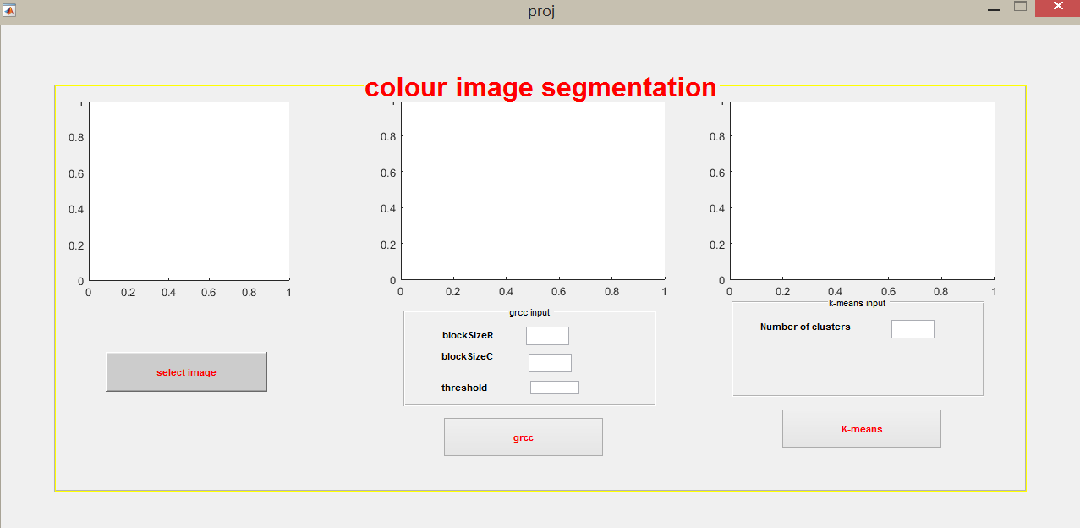

3. Select any color image by clicking on “select image”

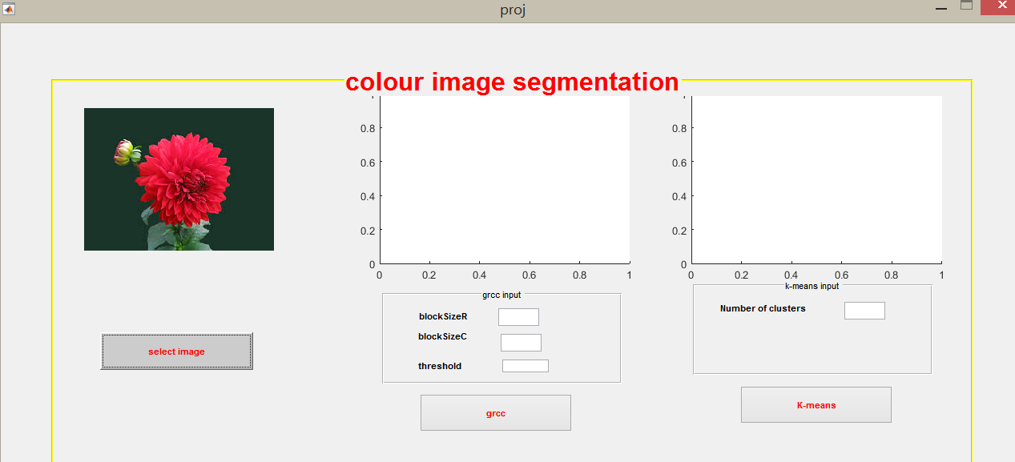

4. Enter row size in “block Size”

Enter column size in “block SizeC”

Enter Threshold value in “threshold”

Threshold values should be lies between (0.0-1.0)

By clicking GrCC we apply GrCC algorithm

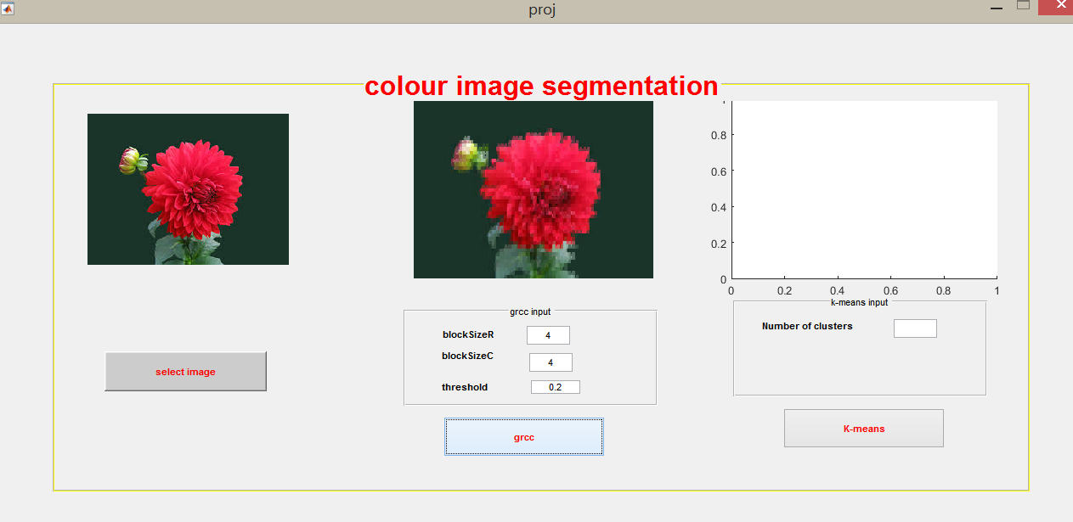

5 enter number of clusters

By clicking on k-means we apply k-means cluster algorithm

